4/10/2019
An Overview of Complexity-based Economic Report and Production Analysis

Heyang Huang, Soulaymane Kachani, Jiayu Zhao
Columbia University in the city of new york

Contents

- Report Overview 3

- Economic Complexity Index Framework 4

- Economic Complexity…………………………………………….4
- Production Matrix…………………………………………………4
- Diversity and Ubiquity…………………………………………….5
- Economic Complexity Index and Product Complexity Index…….6
- Proximity and Distance……………………………………………6
- Opportunity Gain………………………………………………….6

- Production Analysis 7

- Product Categorization…………………………………………….7
- Actual Development……………………………………………….8
- Regional and Global Comparison…………………………………9

- Product Space Design 10

- Suggested Development Vector………………………………….10
- Sequential Development Strategy………………………………..11
- Sensitivity Analysis………………………………………………14
- Contingency Plan………………………………………………...18

- Macro-level Predictions 19

- Structural Optimality Index………………………………………19
- SOI Examples and Implications………………………………….20

- Concluding Remarks 21

- References 23

An Overview of Complexity-based

Economic Report and Production Analysis

1. Report Overview

After centuries of scientific exploration and technological progress, the world is tightly connected and steps into the era of globalization. However, we are also in an era of diversification. Affected by an increasing volume of international trade and other factors, countries are more specialized than ever in production and have diversified into distinct production patterns. National specialization begets diversity at global level. For geopolitical and historical reasons, countries are facing different economic obstacles and have developed their own strategic solution though trials. Governments are always in need of a reliable metric to assess their strategy so that they can make proper adjustment promptly. That’s the exact metric we aim to establish in the report, which uncovers the economic path countries goes through and puts forward macro-level strategies and contingency plans for governments.

In this report, we examine the period of 2009 to 2014, from the perspective of Gross Domestic Production per Capita and product space. While GDP per Capita, the most popular monetary measure of the market value of all final goods and services produced divided by population, reflects countries’ production capability, it doesn’t take into account the structure of the product space. The product space is the set of industries a country has productive knowledge on, weighted by the relative abundance of such knowledge. Or equivalently, we can define the product space as the set of products a country capable to produce. The structure of product space indicates the amount, quality and “shape” of productive knowledge amassed by countries. The product space determines the potential and sustainability of an economy, which can be exemplified by the prolonged challenges Arab oil exporting countries have been facing. Their heavy dependence on oil production and relative lack of other productive knowledge induce unemployment, vulnerability to oil prices changes, unsustainability of economic growth, and difficulty of shifting to high-end industries.

Countries have accumulated different production knowledge and industrial infrastructure. As a result, the underlying cost of developing an industry can vary extensively, while the profitability of investing in an unfamiliar product also differs to a great extent among countries. If a country doesn’t have a robust machinery manufacturing industry as support, it has to invest enormously to excel at developing high-end weapons. If the productive knowledge imbedded in the industry can unlock the door blocking a country from a wide variety of products of higher complexity, the significance of the industry is far beyond the monetary benefits added up to the GDP per Capita.

Therefore, we implement the Economic Complexity Index framework established in The Atlas of Economic Complexity Index Mapping Paths to Prosperity to evaluate the structure of product space and industries for countries, which are calculated as Economic Complexity Index (ECI) and Product Complexity Index (PCI) respectively. The specific mathematical definition and derivation will be covered in Section 2 below.

We follow the steps discussed in later sections, to construct the ECI framework, derive optimal development strategy, and prove its relaxed optimality by contrasting it with the real-world development strategy. We put forward sequential development strategy for less developed countries to optimize the expansion process of their product space. We also design sensitivity analysis and contingency plan to prepare developed and fast developing countries for upheavals in their product space, especially solutions to deal with a possible collapse of their cornerstone industries.

We attach the national report of fifteen characteristic countries to exemplify the metric and provide some intuition of what these countries are facing and how they resemble and differ from each other. The path of economic development is rife with uncertainty and misleading signals. All strategies and description derived in national reports are not one hundred percent precise or determined. In fact, we have mentioned some key hindrance that engenders such bias later in the report. We hope our report can give politicians and scientists, especially those who have access to confidential national production data, some valuable reference on the effectiveness of economic development from a perspective of economic structure.

2. Economic Complexity Index Framework

2.1 Economic Complexity
The production of goods can be decomposed into a bundle of productive knowledge pieces. For instance, the production of a book requires papers and ink, etc. To further break it down, the production of paper replies on the agricultural knowledge of planting trees, machinery knowledge of building printers, and a wide range of expertise, such as papermaking. We can treat a product as a composition of relative productive knowledge, just as a manufactured combination of raw materials. The total quantity and range of productive knowledge determines the product space and productivity of a country. The complexity of an economy is, therefore, related to the multiplicity of productive knowledge amassed. To be more specific, Economic Complexity is a measure of the capability for an economy to structure and utilize the productive knowledge it has acquired.

2.2 Production Matrix: M_{cp}

With no authoritative and universal data source regarding production by industries, we estimate the production by volume of export provided by UN COMTRADE. This rough approximation is a major source of discrepancy. Export is affected by political, geographical and all kinds of factors, hence cannot precisely represent the production. In the scope of the report, the production and export are the same measurement. For those readers who indeed have access to the production data, replacing the export by production dataset should enhance the performance of the metric to a great extent.

Instead if absolute advantage in production, we are more interested in the comparative advantage when we discuss how dominant a country is with respect to a product. Due to the size and population, China is likely to have a larger volume of export in almost every product compared to Cambodia. However, in practice, Cambodia is always comparatively dominant in some products of which the national production divided by the sum of national production of all products are higher than China. Similarly, we use comparative measure to offset the fact that some products are always produced in a larger quantity across countries.

Balassa defines Revealed Comparative Advantage (RCA) as “a country has Revealed Comparative Advantage in a product if it exports more than its “fair” share, that is, a share that is equal to the share of total world trade that the product represents.”

Formally, given the volume of production for a pair of country c and product p, we define RCA_{cp} as

$${RCA}_{cp}=\frac{X_{cp}}{\sum_{c}{X_{cp}}}/\frac{\sum_{p}{X_{cp}}}{\sum_{c,p}{X_{cp}}}$$

Accordingly, we define the matrix of comparative advantage in production for countries and products. “1” indicates the advantage, while “0” indicates the opposite.

$$M_{cp}=\left\{ \begin{aligned}1 { RCA}_{cp}≥1 \\ 0 Otherwise\end{aligned}\right.$$

2.3 Diversity and Ubiquity

We definitely can use a sword to peel an apple, since the sword is sharp, portable and qualified in all extents for peeling an apple. Analogically, sword has all the ‘productive knowledge’ required to peel an apple. In contrast, your laptop or Calculus textbook may not be good choices.

In contrast, as long as we have access to handy peelers and knives, we are less likely to use the sword, because peeling an apple doesn’t seem to be a difficult task and we have tons of options. However, if we live in a world with only a sword, laptop, Calculus textbook, and apples, then sword suddenly becomes the most “elegant” apple peeler. Whether sword is good at peeling apple also depends on the amount and competitiveness of other candidates.

Analogically, when we want to determine how dominant a country is in making a certain product, we have to consider the variety of productive knowledge the country holds, and the difficulty of making the product defined by the productive knowledge required in production.

Diversity and Ubiquity are respectively such crude estimators that are formally defined below:

$Diversity=k_{c,0}=\sum_{p}{M_{cp}}$ (1)

$Ubiquity=k_{p,0}=\sum_{c}{M_{cp}}$ (2)

As shown in the apple peeler analogy, the Diversity and Ubiquity are a pair of complements and can be used to iteratively correct each other. For a country with high Diversity, we go through the Ubiquity of all products the country makes to determine whether the high Diversity attributes to exceptional productivity or a mass production of low-end products. For a product with high Ubiquity, we examine the Diversity of all its production sources to determine whether the high Ubiquity indicates the product to be high-end or just less demanded. In a few iterations, the effectiveness of correction converges to zero and the cross-correction process terminates.

$k_{c,N}={\frac{1}{k_{c,0}}\sum_{p}{M_{cp}} k}_{p,N-1}$ (3)

$k_{p,N}={\frac{1}{k_{p,0}}\sum_{c}{M_{cp}} k}_{c,N-1}$ (4)

Plug the value of $k_{p,N}$ into the equation of $k_{c,N}$, we derive

$k_{c,N}=\frac{1}{k_{c,0}}\sum_{p}{M_{cp}}{\frac{1}{k_{p,0}}\sum_{c'}{M_{c'p}} k}_{c',N-2}$ (5)

$k_{c,N}=\sum_{c'}{k_{c^{'},N-2}\sum{\frac{{M_{cp}M}_{c'p}}{k_{c,0}k_{p,0}}}}$ (6)

Or for simplicity,

$k_{c,N}=\sum_{c'}{M_{cc'}}k_{c^{'},N-2}$ (7)

where $M_{cc'}=\sum_{p}{\frac{{M_{cp}M}_{c'p}}{k_{c,0}k_{p,0}}}$ (8)

2.4 Economic Complexity Index and Product Complexity Index
The largest eigenvector of M_{cc’} is a vector of ones, which satisfies the equation (7)
By definition, the second largest eigenvector $\vec{K}$ that best preserves the information about variance in the system, which is just Economic Complexity. Hence, we define the Economic Complexity Index ( ECI) as:

$ECI=\frac{\vec{K}-<\vec{K}>}{stdev(\vec{K})}$ (9)

where < > stands for numeric mean, and stdev stands for the standard deviation.

For the same token, we plug the $k_{c,N}$ into the equation of $k_{p,N}$ , calculate the second largest eigenvector $\vec{Q}$ of M_{pp’,} and define Product Complexity Index ( PCI) as

$PCI=\frac{\vec{Q}-<\vec{Q}>}{stdev(\vec{Q})}$ (10)

Where < > stands for numeric mean, and stdev stands for the standard deviation.

2.5 Proximity and Distance

As aforementioned, the economy is always facing multiple paths in the journey of economic development, or equivalently, expansion of product space. While a certain sequence is efficient and reasonable for some countries, it may not be the case for others. Certain products are close substitute. They share high proximity in a sense that possessing the productive knowledge embedded in their production resembles to each other. We then define connectedness of z product as the numeric average of proximity of it to all other products. After calculation, high-end products clearly exhibit high connectedness, while rudimental products tend to be far away from other products. The intuition is to the joint probability of co-producing two products as the estimator of proximity. However, this doesn’t work out well. Instead, we use the minimum between the conditional probability of exporting product p given the country is currently exporting product p’ and that of exporting p’ given the country is exporting p, as our measure. We choose the minimum of each pair of conditional probability to minimize the false positive rate.

$∅_{pp'}=\frac{\sum_{c}{{M_{cp}M}_{cp'}}}{{max(k}_{p,0,}k_{p',0)}}$ (11)

The difficulty for a country to produce a product outside its product space is simply the connectedness of the product to all products currently in the product space. We normalize it formally define it as Distance.

$d_{cp}=\frac{\sum_{p'}{{(1-M}_{cp'}})∅_{pp'}}{\sum_{p'}{∅_{pp'}}}$ (12)

2.6 Opportunity Gain

We are still in need of an estimator of profitability. Again, the profit of exploring a new product is not limited to the increase of GDP, or any figures on fiscal report. It’s more about the decrement of Distance to all other products far away from the product space. Such products should not be weighted uniformly. The more complex a product is, the higher value it should be assigned. We first calculate the total unexploited value for a country c, before and after the advance of a new product. The difference should be the “revenue” for the country c to develop product p. The “cost” is just a measurement of the difficulty of developing the product. The Opportunity Gain is simply the “revenue” net of “cost”. There is a trade-off between the increment of Total Unexploited Value and the difficulty of developing the product. While the advance of a new product draws all products closer to the product space, the low complexity and huge distance of the product also incur a cost. If the product is an extreme outlier far from the product space, and is loosely connected to other products, the Opportunity Gain can even go negative.

$Total Unexploited Value=\sum_{p'}{{(1-d}_{cp'}){(1-M}_{cp'}}){PCI}_{p'}$ (13)

${Opportunity Gain}_{cp}=\sum_{p'}{{\frac{∅_{pp'}}{\sum_{p''}{∅_{p''p'}}} (1-M}_{cp'}}){PCI}_{p'}-$ ${(1-d}_{cp}) {PCI}_{p}$ (14)

The concept of Opportunity Gain, as well as ECI, is the foundation of the metric we introduce in the report. It’s important for us to understand that Opportunity Gain is only a conceptual estimate of the net gain of developing a product. It’s not measured in dollars or any real-world units. It is expressed in term of productive knowledge, and is too conceptual to be implemented in strategy making process directly. That’s why we further elaborate on the Opportunity Gain to calculate the marginal Opportunity Gain later in Section 4.

3. Production Analysis

3.1 Product Categorization
Our main data source in this research is the UN Comtrade Website (https://comtrade.un.org), which provides us with valuable information on countries’ export data on an annual basis, including highly specific export data for more than 5000 categories of products. In order to have a holistic vision of the product space of a country, however, a level of categorization is required. Product groups in UN Comtrade are labelled from 010000-999999, with the first two-digits representing a general category to which the product belongs. Based on the 99 categories as extracted from the label, we further group the products into 18 major and widely-accepted industry categories, as summarized in Table 1.

Note that the high-tech industry group is not a distinct industry but rather an aggregated industry that encompasses the most complicated products from the most technologically-advanced industries (as measured by PCI). This industry serves as an indicator for us to quantitatively evaluate how well a country has performed in developing cutting-edge technologies and closing its technical gap with advanced economies, which has become a topic of wide concern today. Indeed, when we rank the 18 categories based on PfCI (i.e., Product Family Complexity Index, an equivalent concept of PCI calculated based on the 18 categorized product families), high-tech industry has the highest PfCI among all industry families.

Category | Description
Animal and By-product | All kinds of meat, livestock and related by-products
Vegetable, Fruit and Plant | All kinds of plants, edible vegetables and fruits
Food and Preparation | Edible preparations, raw cooking materials and appliances
Mineral and Stone | Mining industry for mineral and stone materials
Chemical | Raw chemical materials and by-products
Chemical Manufacturing | Advanced chemical products and pharmaceutical products
Raw Manufacturing | Basic products made from plastic, rubber, leather, etc.
Wood Product | Book, paper and other elementary products related to wood
Clothing and Accessory | All kinds of fabrics, filament, clothing and accessories
Textile | All kinds of textile articles and related products
Metal | Mining of all sorts of raw metal
Machinery | Machinery and mechanical appliances, including electrical equipment
Transportation | Vehicles and locomotives including aircraft, ship, railway, etc.
Weapon | Explosives, arms and ammunition
Daily Instrument | Basic daily instruments such as sport requisites, timing and measuring tools
Precious Stone | Refined or processed stone products such as pearl and ceramics
Service | Financial, business, legal, communication, travel services, etc.
High-tech | Agglomeration of advanced products with highest PCIs

Table 1: Categorization of Products

We further observe a strong positive correlation between the GDP and the export of high-tech products. As shown by Figure 4 below, a high adjusted R-square of 67.6% exists between GDP and high-tech exports, indicating that more successful economics, as measure by GDP, tend to be those that are capable of producing and exporting high-tech products as we defined.

Statistics | Value
Multiple R | 0.824
R-Square | 0.679
Adjusted R² | 0.676
Variable | Value
Coefficient | 12.20
t-stat | 15.61
P-value | 0(***)


Figure 1: Regression of GDP and High-tech Exports

3.2 Actual Development
Based on the product categorization aforementioned, the first step to understanding the prodict space of different economies is to capture their production strategies between 2009 and 2014 on a complexity level. In Hausmann and Hidalgo (2009), distance is defined to be a measure of how far a country is from a certain product not in its product space, as in (12). We extend this concept to all product families and quantify how technically equipped a country is to develop corresponding product families. In other words, the shorter the distance between a country and a product group, the more capable a country is in developing products within that group.

Based on this concept of distance between countries and product families, we defining the net distance change between two periods as the Actual Developmental Index (ADI), which measures by how much a country has moved in the direction of a certain product family in its product space during the period. Our export data allows us to calculate and compare ADI of countries over the 18 product groups from 2009 to 2014, where a positive ADI indicates a shortening of the distance (i.e., relative advancement of the industry), and a negative ADI indicates the reverse. Note that this number is a normalized value that represents relative distance change in a global scale, and thus a negative value implies not an absolute degeneration of a certain industry, but rather a relative prioritization of other industries.

As shown by the example of China in Table 2, during the period from 2009 to 2014, China has focused on products with a moderate level of complexity and those requiring intermediate skills, including service, machinery and high-tech, which are rather advanced among developing economies. By advancing into 8 out of the 18 industry families, China now has a greater distance with the other industries ranked below.

Category | ADI | Category | ADI
1. Precious Stone | 0.062 | 2. Service | 0.034
3. High-tech | 0.033 | 4. Machinery | 0.023
5. Chemicals | 0.015 | 6. Raw Manufacturing | 0.006
7. Food and Preparation | 0.005 | 8. Weapon | 0.002
9. Mineral and Stone | -0.005 | 10. Clothing and Accessory | -0.006
11. Vegetable, Fruit and Plant | -0.009 | 12. Metal | -0.012
13. Transportation | -0.014 | 14. Wood Product | -0.023
15. Textile | -0.029 | 16. Daily Instrument | -0.035
17. Animal and By-product | -0.044 | 18. Chemical Manufacturing | -0.063

Table 2: Actual Developmental Index (ADI) of China

3.3 Regional and Global Comparison
The next question to ask is how the strategy adopted by countries differ from each other and what trends we can observe. Table 3 and 4 below summarize the production strategies, as measured by ADI, adopted by a selected group of developed and emerging economies in the world, respectively. It can be directly observed that leading economies, such as U.S. and Germany, in general focus on products with higher level of complexity. However, variations also exist and some developed economies, such as France, still give a considerable level of attention to product families of intermediate-level complexity, such as raw manufacturing and chemicals.

Ranking | France | USA | Germany
1 | Raw Manufacturing | Service | Chemicals
2 | Mineral and Stone | Chemical Manufacturing | Service
3 | Precious Stone | Food and Preparation | High-tech
4 | Chemical Manufacturing | Textile | Transportation
5 | Chemicals | Clothing and Accessory | Food and Preparation

Table 3: ADI Comparison across Leading Economies

Ranking | China | South Korea | Singapore | India
1 | Precious Stone | Chemicals | Machinery | Daily Instrument
2 | Service | Machinery | Transportation | High-tech
3 | High-tech | High-tech | Daily Instrument | Wood Product
4 | Machinery | Weapon | Chemicals | Machinery
5 | Chemicals | Precious Stone | High-tech | Chemicals

Table 4: ADI Comparison across Emerging Economies

Table 4 further examines the development strategies adopted by emerging economies in the world. Reasonably, emerging economics such as China, South Korea, Singapore and India have devoted the majority of their efforts into intermediate industry groups while developed economies rely more on advanced industry groups. This trend holds true in general, regardless of the continent or the time period, and thus could serves as an indicator for which phase of development a country is currently in as evaluated from their production strategy. Nevertheless, in order to more quantitative evaluate the effectiveness of different development strategies, we dive into the product space in depth in the next section to understand how countries should develop on an individual basis.

4. Product Space Design

4.1 Suggested Development Vector
As aforementioned, distance gives us an idea of how far each new product is from a country’s current mix of exports. As defined in Hausmann and Hidalgo (2009), distance is “the weighted proportion of products connected to goods p that country c is not exporting, i.e., MCP=0.” Based on this definition, the distance between a country and any product that the country is currently exporting (i.e., the country is a significant exporter in the product as compared to global average) is zero. Similarly, opportunity gain quantifies the contribution of a new product in term of opening up the doors to more and more complex products, as in (14). Intuitively, a product that a country is currently exporting (i.e., MCP=1) has an opportunity gain of zero. And unreasonable investment on certain product p would lead to a relative decrement in export of more profitable products, and therefore lead to a negative opportunity gain of product p. The opportunity gain is not the only estimator of a country’s level of economic development. However, among countries with comparable economics quantity, those having higher ECI often have economics structures that are in better shape.

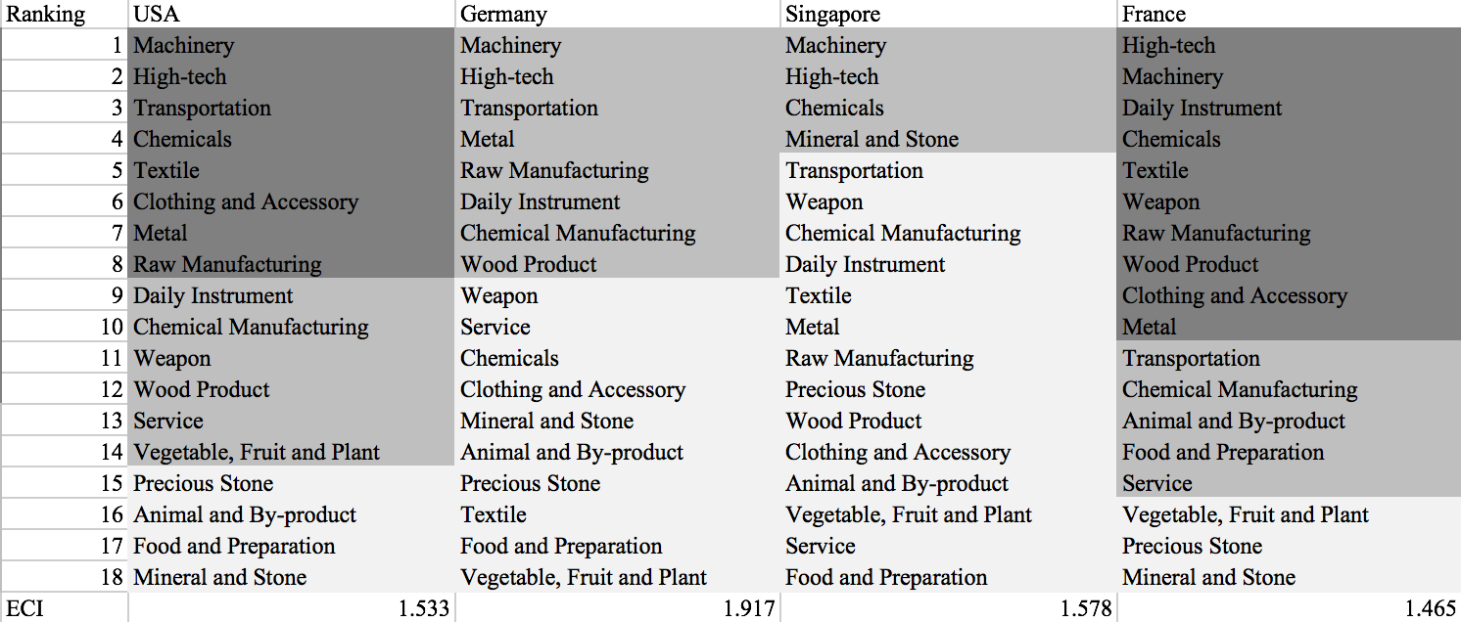

Table 5: Opportunity Gain Ranking of Leading Economies

We define the ranking of opportunity gain for a country c, as the Suggested Development Vector (SDV) of c. Table 5 summarizes the SDV of leading economies in the world, with the industry groups ranked in decreasing order of significance. Dark grey indicates positive opportunity gain, gray indicates zero opportunity gains, and light grey indicates negative opportunity gains. The result shows that leading countries barely have any industries with positive opportunity gain. In other words, those countries are already in the most stable and efficient economic structure. Without the necessity of economic transition, those countries merely need to maintain a steady and balanced economic development. In contrast, developing countries such as Brazil and India have nearly half of industries with positive opportunity gain, and share common interests in manufacturing and machinery, as shown below in Table 6. It is noteworthy that not all leading economies have reached a stable equilibrium in terms of their economic structure, and in fact, it is possible for developing economies to have better balanced economic structures, despite the fact that their output quantities might not be as significant on a global scale. The result shows as that the analysis conducted on an economic complexity level might serve as a complement to existing economic indicators such as GDP, which provide information on quantity but not quality of countries’ economic progress.

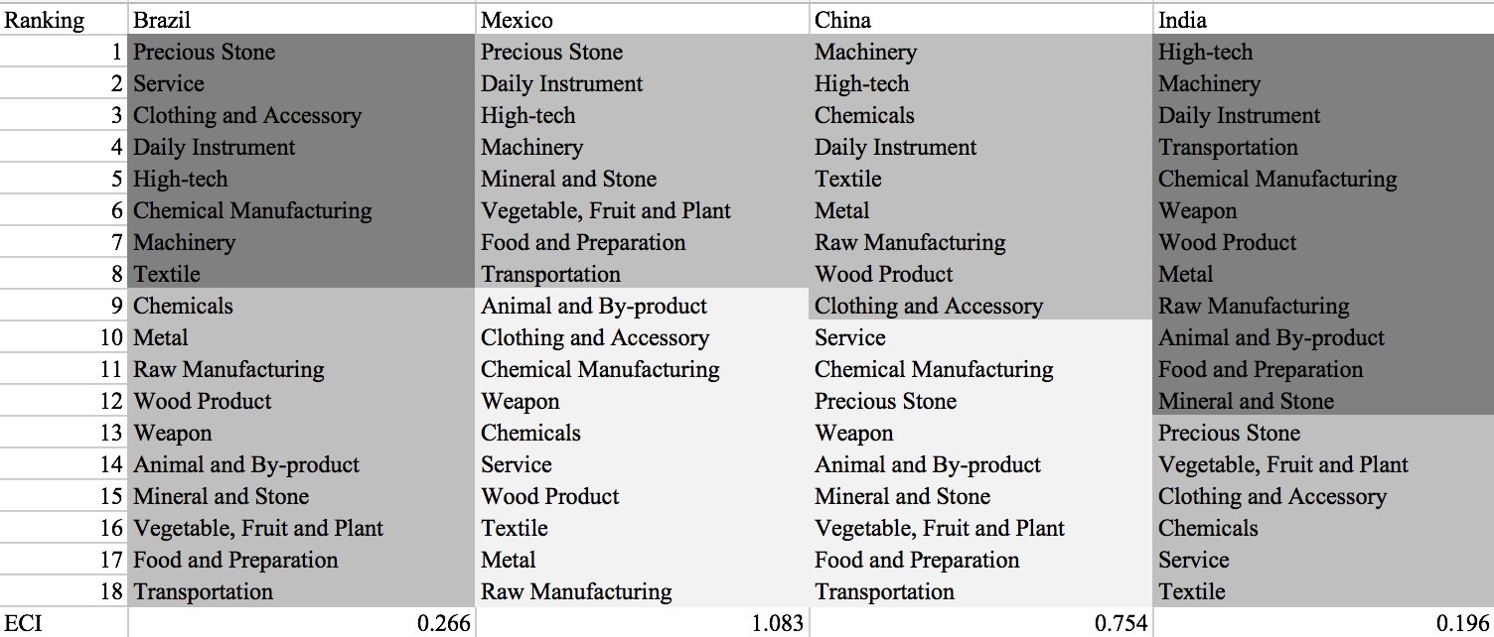

Table 6: Opportunity Gain Ranking of Emerging Economies

The aforementioned differences in economic structure between relatively advanced economies and developing economies imply that we need to adopt different methods for analyzing economies in different stages. For countries that have a large number of industries with positive opportunity gains, we need a sequential strategy that allows prioritization of certain industries to develop in the first stage. On the other hand, for countries that have already obtained a relatively stable economic structure, it is more important to answer questions such as how sensitive the countries are to shocks in various industries and what their contingency plans should be in those cases. Therefore, the rest of section 4 provides methods and examples to analyze those two groups of countries in a separate manner.

4.2 Sequential Development Strategy
The sequential economic development strategy aims to approximate the most efficient order of industrial development for countries with multiple industries to advance into. As discussed in the previous section, opportunity gain measures the potential profit in terms of economic complexity when a country invests on a product p to an extent such that the MCP bumps up from 0 to 1 (i.e., the country becomes a significant exporter in that product). Obviously, the difficulty of bumping up MCP varies across industries. Thus, we capture this variation of difficulty by defining the concept of marginal opportunity gains.

$$Marginal Opportunity Gain_{cp}= \frac{Opportunity Gain_{cp}}{\left(\frac{ \frac{\sum_{p}{X_{cp}*\sum_{c}{X_{cp}}}}{\sum_{c,p}{X_{cp}}}-X_{cp}}{Xcp}\right)}= \frac{Opportunity Gain_{cp}}{\left(\frac{\sum_{p}{X_{cp}*\sum_{c}{X_{cp}}}}{X_{cp}*\sum_{c,p}{X_{cp}}}-1\right)}$$

In each iteration, we order all 18 industries based on their current marginal opportunity gain, and prioritize the industry with the highest marginal opportunity gain. We increase the prioritized industry’s export to an extent that the MCP firmly bumps up to 1. Then we re-perform calculations on countries’ marginal opportunity gains and update the next industry for the country to develop. Following this algorithm, we derive the iterative strategy for Morocco as an example. In Table 7, the industries are ranked by marginal opportunity gains in decreasing order, where dark grey indicates positive opportunity gain, gray indicates zero opportunity gains, and light grey indicates negative opportunity gains.

Table 7 shows that at present Morocco lacks necessary industrial power, and therefore barely has advantage in manufactured goods. Basic products such as textile, food and preparation are the foundation of intermediate-level products, and industries such as raw manufacturing and daily instrument are the second easiest step. It is noteworthy that the significance of high-tech drops extensively after the development of service re-opens the door of light industries and intermediate-level industries such as transportation and metals. Because Morocco has a large gap between its current product space and advanced product groups such as high-tech and machinery, it is extremely costly for Morocco to develop these two products even in the final stable stage, and Morocco may have a compelling industrial structure without a comparative edge in these two industry groups.

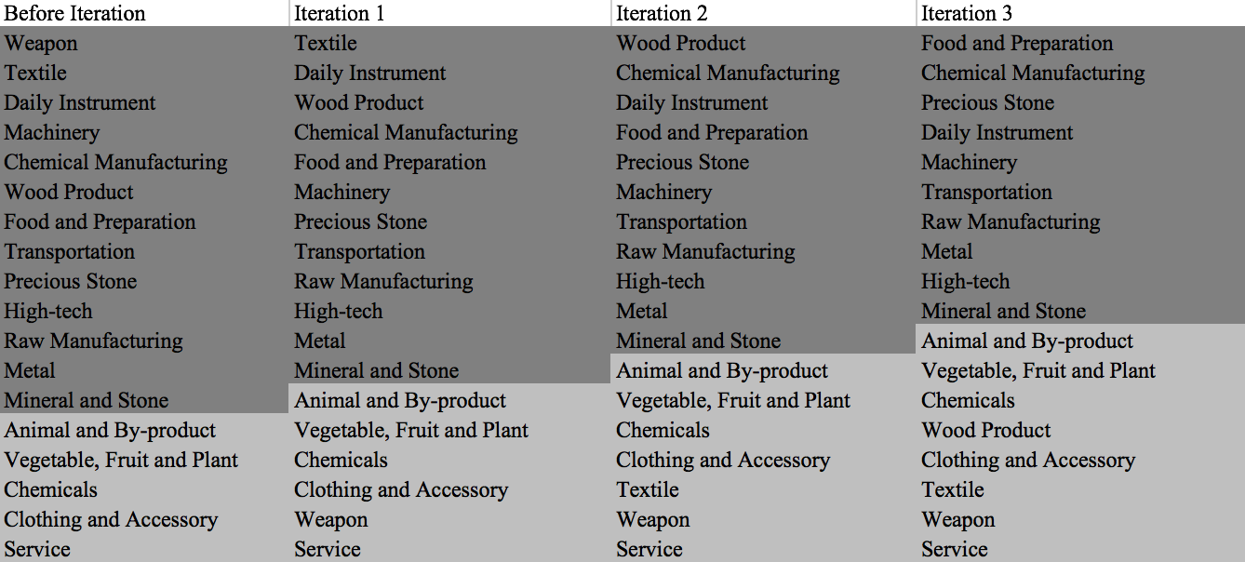

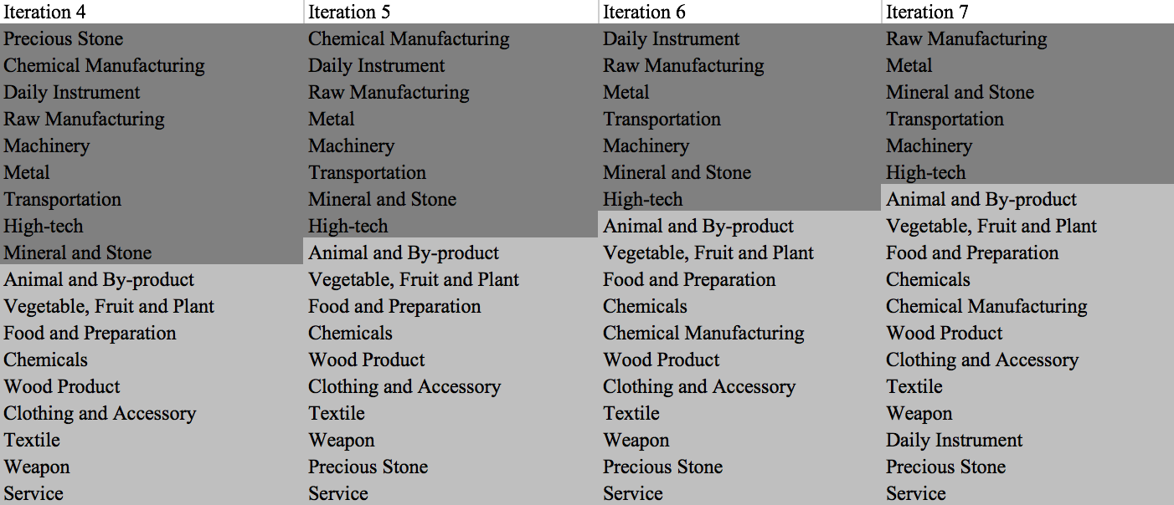

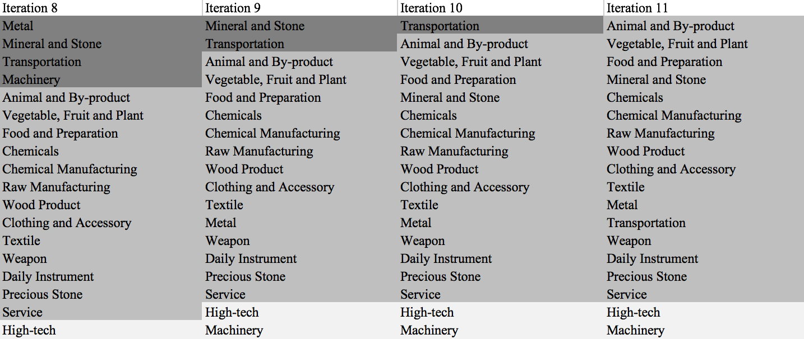

Table 7: Sequential Development Strategy of Morocco

Note that high-tech and machinery show negative marginal opportunity gain at the final stable stage, but that does not mean the two industries are valueless for the development Morocco. Instead, the suggestion means that Morocco, given to its economic situation at the final stage, is encouraged to prioritize the other industries and develop those bottom two industries only after it builds a balanced economic structure in the first place. The industries with negative opportunity gains, though not prioritized in their particular stage, should therefore still be proportionately strengthened within the capability of the country and not left behind.

Another example of sequential development strategy is provided for Turkey in Table 8 below, a country that is famously on the edge of being classified as developed/developing economies. Reasonably, it takes fewer iterations for Turkey to reach a stable economic structure given that Turkey already has a comparative advantage in many important industry groups.

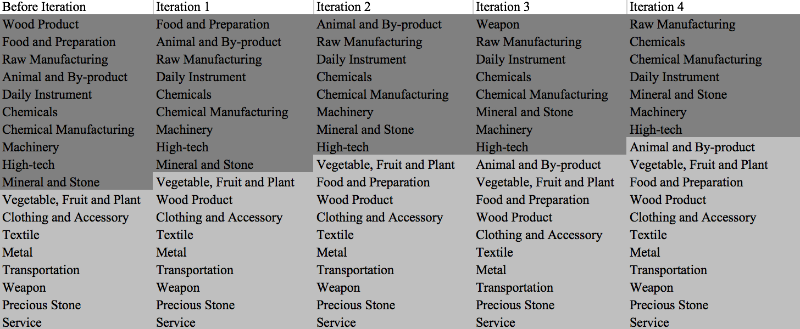

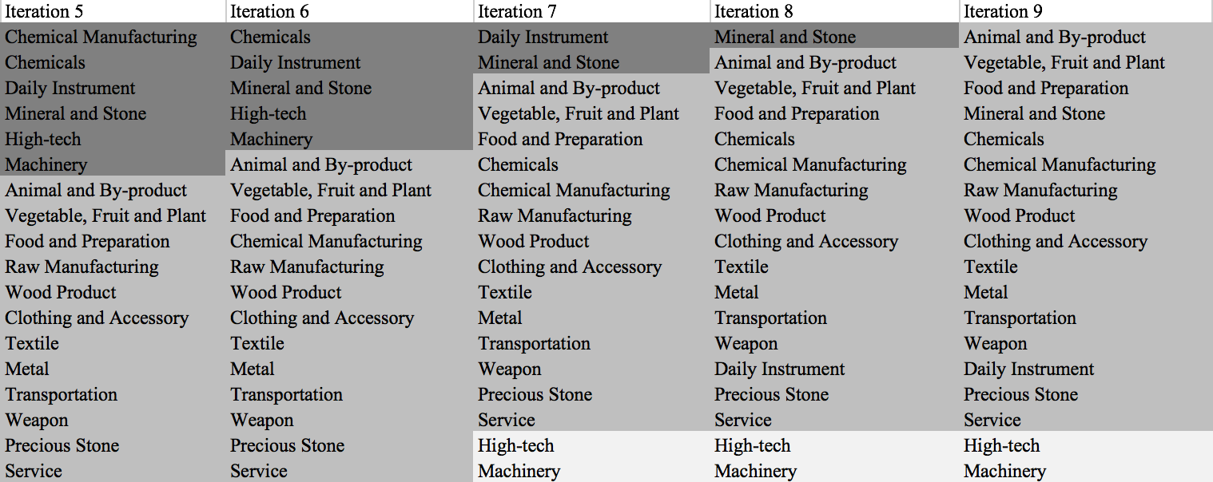

Table 8: Sequential Development Strategy of Turkey

The sequential development strategy above applies when a large number of industries with positive opportunity gains are being considered, and may serve as a general reference for countries in deciding which industries to prioritize by providing information on the dollar-weighted costs of developing these industries. However, since we are pivoting the algorithm on industries of one certain country, the strategy admittedly ignores dynamics of concurrent development in other economies, i.e., possible changes in economic structure of other countries and trade flows on a global scale. In reality, the predicting power of the sequential development strategy might not be strong when the planning horizon is too long, and countries should probably consider only the first few iterations when making prioritization decisions. Nevertheless, the strength of this algorithm lies in the fact that it is easy for countries to re-calculate/update the strategies once new export information becomes available. Moreover, it is meaningful to for countries to make such calculations on a rolling basis and observe how their prioritizations have changed in the past years and whether new adjustments are needed.

4.3 Sensitivity Analysis

It’s worth noting that the Sequential Development Strategy is not universally applicable to all countries. It’s designed for less developed countries that have many positive Opportunity Gain industries. If there’s barely any positive Opportunity Gain industries, the Sequential Development Strategy obviously is obviously meaningless. In fact, most developed and fast developing countries fall into the category and their Suggested Development Vectors (SDV) exhibit a similar pattern, as shown below.

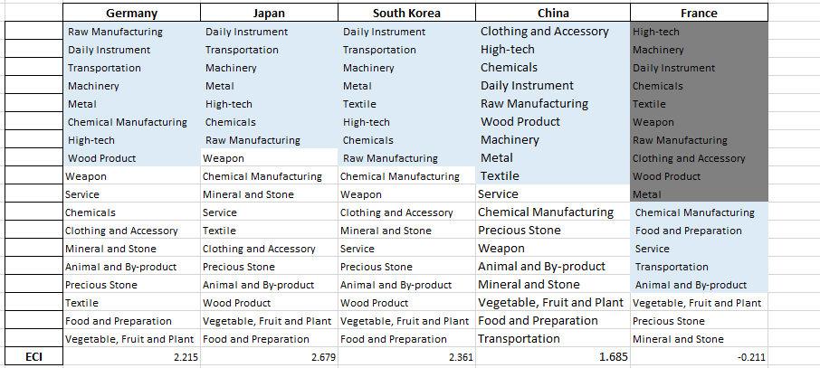

Table 9: SDV of Developed and Fasting Developing Countries in 2009

However, there are also extreme cases, such as France in 2009. Financial hardship resulting from the global economic crisis have led to strikes, unemployment and other forms of widespread social unrest. Such upheavals further contribute to a massive regression in all industries. Hence, even though France is a well-developed country, it can also exhibit a SDV with many positive Opportunity Gain industries, which precisely represents the hardship France went through back in 2009.

Therefore, instead of focusing on how to further balance the structure of product space, developed countries should take precautions against unexpected strikes and forecast the adverse effects industry by industry. The regression of an industry with low PCI and low Opportunity Gain is less dangerous than that of cornerstone industries. High-tech is such a representative of the cornerstone industries, because High-tech connects to most of the profitable products that developed countries are currently specializing in. For the same token, Food and Preparation is one of the less fundamental industries for developed countries. Such intuition can be rigorously proved by the sensitivity analysis we are about to introduce.

The sensitivity analysis aims to approximate the volatility of SDV subject to an instant increment or decrement of export and is mainly implemented on developed countries that

have few industries with positive opportunity gains. To be more specific, sensitivity score is the least-squared slope for the linear regression between percentage change of production for

Country C and Product P and the E _{f} CI of C.

When the opportunity gain of the industry is negative, the sensitivity analysis approximates how an over-development of the industry jeopardizes the economic structure of a country. When the opportunity gain of the industry is zero, the sensitivity analysis determines whether the further development of the industry shapes the country a better economic structure, and predicts how the SDV would change accordingly. Specifically, as we reduce the export of such an industry to 25%-50% of its original value, a few other industries originally with negative opportunity gain would probably become profitable. We separate the increment and decrement of production in the sensitivity analysis, because they tend to show vast difference. The extreme profitability of a spike of production doesn’t imply a shrink is always followed by a painful crisis.

We perform the sensitivity analysis of the aggregate of top ECI countries, including US, UK, Korea, Japan, South Korea, Singapore, Germany, and France, and use the result as the benchmark. The sensitivity score in 2014 and 2009 are shown in Table 0 and Table 11 respectively:

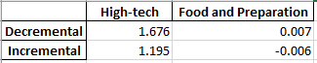

Table 10: Sensitivity Score of Benchmark in 2014

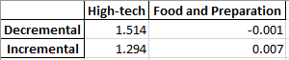

Table 11: Sensitivity Score of Benchmark in 2009

We observe a similar pattern that the Sensitivity Score of Food and Preparation is approximately 0, while the Decremental Sensitivity Score is larger than the Increment. We can therefore make three conclusions here.
- The disturbance in Food and Preparation industry exert a trivial impact on the E_{f}CI of a country, which echoes with our intuition that Food and Preparation is of minimal significance to the structure of product space of developed countries or fast developing countries.
- The High-tech industry is the cornerstone industry of most developed or fast developing countries.
- The reward of an increase of High-tech production is less than the jeopardy of a decrease in the same extent.

Besides the sensitivity score, we are interested in the shift of SDV caused by upheavals in different industries. The shift of SDV gives us a good vision of how the production pattern is going to be. The results of Benchmark in 2014 are shown below in Table 12-Table 15

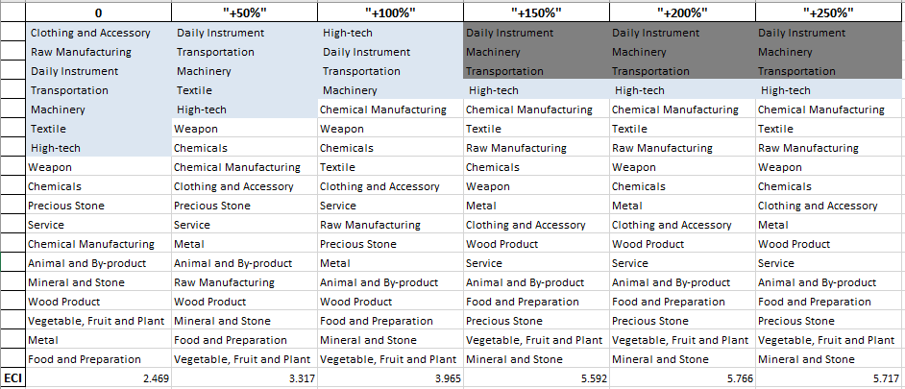

Table 12: Incremental of High-tech Production for Benchmark in 2014

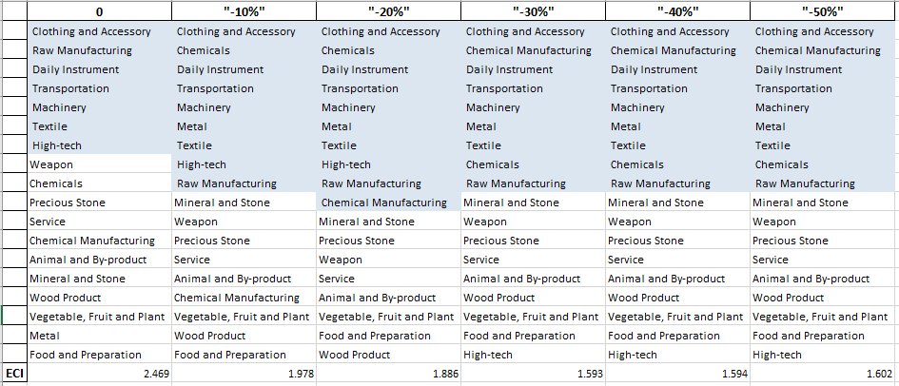

Table 13: Decremental High-tech Production for Benchmark in 2014

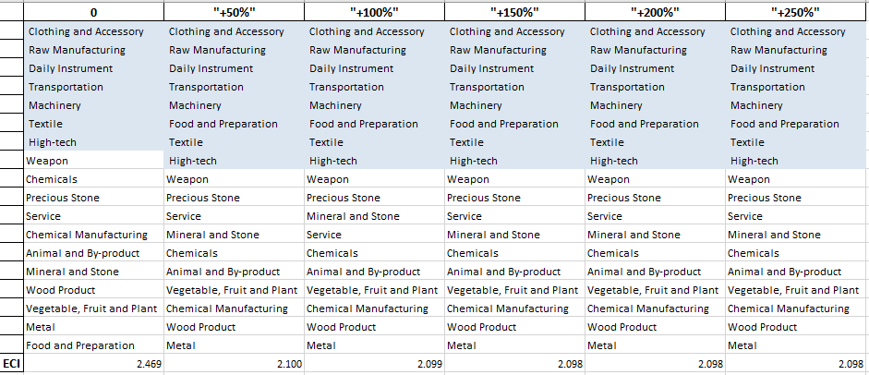

Table 14: Incremental Food and Preparation Production for Benchmark in 2014

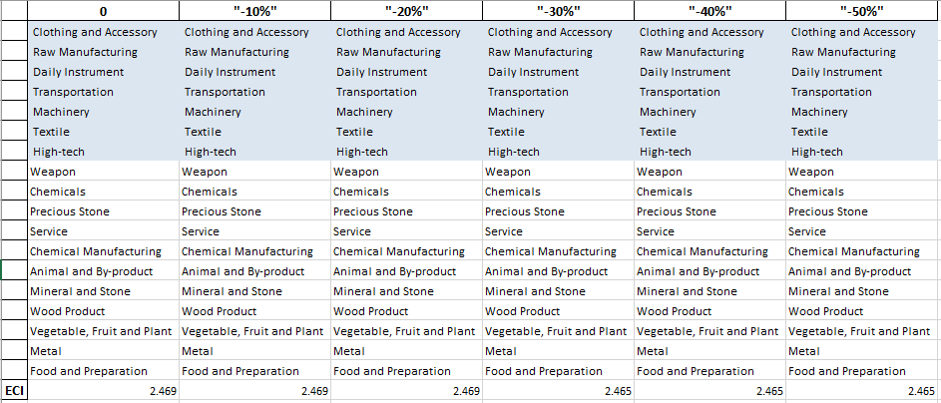

Table 15: Decremental Food and Preparation Production for Benchmark in 2014

As we expect, the shift of Food and Preparation production doesn’t alter the SDV at all. In contrast, the boom of High-tech can stimulate and bring extra potential to other high complexity industries, including Machinery, Transportation and Daily Instrument.

4.4 Contingency Plan
The Contingency Plan aims to present a set of solutions with respect to upheavals in different industries. Instead of compensating for the declining production directly, the best strategy is to develop those incipiently profitable industries. In this manner, we can derive the contingency strategy for countries to deal with possible abrupt declines of crucial industries. In some cases, the SDV remains unchanged even when a zero-opportunity-gain industry declines to its 20% in terms of export. We can then conclude the industry is not indispensable to the country. The contingency plans for US and China in 2014 are shown in Table 16 and Table 17 respectively.

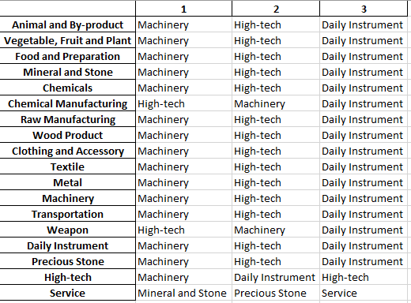

Table 16: Contingency Plan for US in 2014

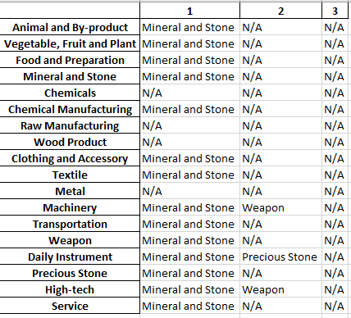

Table 17: Contingency Plan for China in 2014

As a clarification, the three consequential N/As means that the country doesn’t even need to respond to a collapse in the industry.US and China have distinct solutions to the up and down of the same industry. While the solution for US is highly industrial, Mineral and Stone is the panacea for China. It’s worth noting that the Service industry in US differs from all other industries, we will further discuss the reason behind in the national report of US.

5. Macro-level Predictions

5.1 Structural Optimality Index
Indeed, such choice of prioritization has proven to be a significant factor in deciding the economic outcomes of countries. In order to quantitatively evaluate how effective our development strategies are and how deviations from the suggested developmental path will lead to suboptimal growth results, we define the measure – Structural Optimality Index (SOI) – on a country level as the R-Square obtained from regressing the country’s actual development over the suggested development strategy. Both strategies are quantified in nature, with the actual development represented by export increase in every major industry groups and the suggested development strategy represented by the opportunity gains of developing the corresponding industry groups as calculated in previous sections. The adjusted R-square from the regression thus provides us with a quantified measure of how the development path adopted by the country has fitted with/differed from calculations on a complexity level.

After obtaining this measure for all countries in our database, we further regress countries’ five-year economic growth, which as defined as the net increase in GDP (USD), over their SOI. Figure 6 illustrates the regression output, which shows a strong positive correlation between countries’ SOI and their five-year GDP growth, significant at the 1% level and achieving an adjusted R² of 11.9%. In other words, the more a country develops as suggested by calculations on a complexity level, the better economic outcomes it achieves.

Statistics | Value
Multiple R | 0.355
R-Square | 0.126
Adjusted R² | 0.119
Variable | Value
Coefficient | 1.249*10¹²
t-stat | 4.061
P-value | 0.000(***)


Figure 2: Regression of Five-year GDP Growth over SOI

5.2 SOI Examples and Implications
To explain this finding in a more intuitive way, we take China and France as a comparison. As the regression in Figure 7 suggests (the orange curve represents export increase and the blue curve stands for opportunity gain of the corresponding industry), the export increases of China in various industries demonstrate a high level of correlation with the opportunity gains of those industries, having an adjusted R-square (i.e., SOI) of around 82.8%. In fact, China ranks the 1st place among all countries in terms of SOI, meaning that it is developing in quite an optimal way, and also ranks the 1st place in terms of its economic growth rate from 2009 to 2014, which is consistent with the regression result in Figure 6.

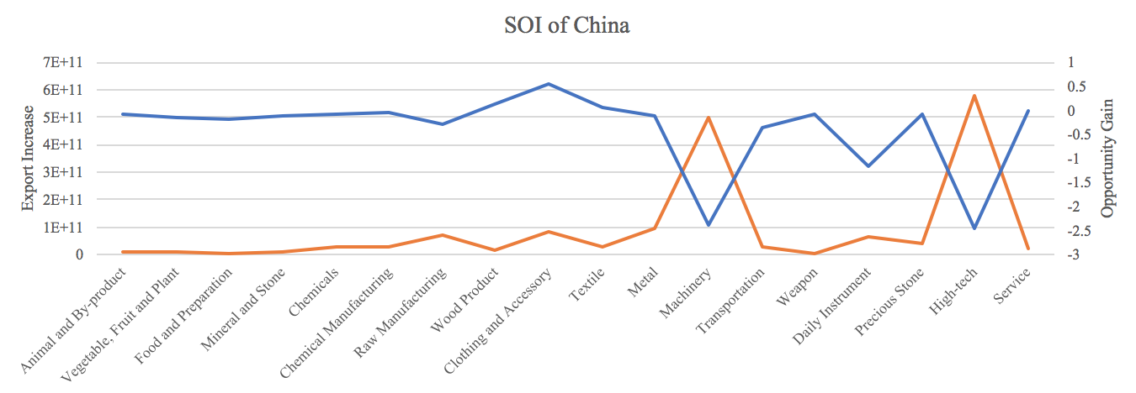

Figure 3: SOI of China (2009-2014)

The situation in China is in direct contrast to that in developed economies such as France, where there is a moderate SOI of around 14.2% and a corresponding annual growth rate of merely 1.1%, ranking it a slow-developing economy during the period. In sum, France’s stagnant economic progress from 2009 to 2014 can be at least partially explained by a mismatched development strategy that demonstrates a considerable level of deviations from the suggested developmental path as calculated through opportunity gains. In specific, Figure 8 shows that France invested/exported heavily in the transportation industry, while it should have focused more on industry groups such as service and machinery, which actually have higher opportunity gains based on calculations.

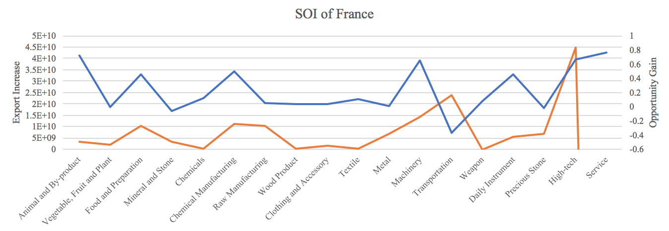

Figure 4: SOI of France (2009-2014)

The contrast of situations in China and France offers a glimpse of the relationship summarized in the regression in Figure 6, and shows that the economic outcome of countries is positively associated with their structural optimality. In particular, countries such as China tend to have better growth, as measured by GDP, when they follow industry prioritization strategies closely based on opportunity gains, and the reverse is true for countries such as France. While a strict causality is hard to be established in this case because it is hard to control variables in such natural experiments, the correlated phenomenon is widely observed across different time spans of our interest. This implied that the calculations and further research on a complexity level are of importance and great values to countries, and may offer a guide for them to properly access and prioritize certain industries in face of practical constraints such as time and budget.

6. Concluding Remarks

In conclusion, we follow the footsteps on previous works related to Economic Complexity Index and put in more analysis on the product space for each country into the general framework. In particular, we categorized the highly specific global export data available on UN Comtrade to 18 manageable and intuitive industry categories. Extending the definitions of product complexity index to product families, we calculate distance between countries and product families in a corresponding manner and observe how countries have positioned themselves in their product space during the time span of our interest.

We then dive into the question of how countries should develop given their current position in the product space and solve for strategies for countries on an individual basis. We propose a sequential development strategy for developing economies to prioritize certain industries in their expansion of their product space. We also put forward sensitivity analysis and contingency plan to prepare developed and fast developing countries for upheavals in their product space, especially solutions to deal with a possible collapse of their cornerstone industries. More detailed analyses of fifteen selected economies can be found in the appendix of this report, and they largely represent how countries of each kind should develop in this ever-changing global market.

In particular, we come up with the structural optimality index to quantitatively measure and compare the strategies adopted by countries against the suggested developmental path. Regression shows a strong positive correlation between countries’ structural optimality and their economic outcomes, measured by GDP growth. This suggests that countries’ product space, as well as decisions to be made on the product space, are of great research values to economies and more works remain to be done in order to obtain a deeper understanding of how countries interact on the global production network.

References

Hausmann, R., Hidalgo, C., Bustos, S., Coscia, M., Chung, S., Jimenez, J., Simoes, A. and Yıldırım, M. (2007). The Atlas of Economic Complexity. [online] Atlas.cid.harvard.edu. Available at: http://atlas.cid.harvard.edu/.

Comtrade.un.org. (n.d.). Download trade data | UN Comtrade: International Trade Statistics. [online] Available at: https://comtrade.un.org/data/.

